

**Abstract**The Contraplano Reporting Module (MRC) is a web solution designed to address critical deficiencies in the current reporting system of Contraplano, a regional digital news media outlet in Chile. The project proposes the development of a module built with Flutter and Firebase, which incorporates validated forms, deduplication, advanced filters, and an administrative panel. Additionally, it will generate exportable reports compatible with Mailrelay and provide dashboards with key performance indicators. The solution ensures data traceability, reliability, and usability, while improving operational efficiency for interns, editors, and management. The MRC directly integrates competencies from the Computer Engineering program such as software development, project management, data modeling, quality assurance, and security, while also reinforcing generic skills such as teamwork, innovation, and professional communication.

1. **PART I**

| **1. Personal Background** |
| --- |

| **Student Name (1)** | Marialejandra Méndez Ramírez |
| --- | --- |
| **Rut (1)** | 26.167.127-1 |
| **Student Name (2)** | Noel Francisco Saenz Labra |
| **Rut (2)** | 21.124.053-9 |
| **Degree Program** | Computer Engineering |
| **Campus** | Maipú |

| **2. Project Description** |
| --- |

| **Project Name** | Contraplano Reporting Module (MRC) (Contraplano is a regional and digital news media outlet in Chile, located in Reñaca) |
| --- | --- |
| **Areas of Performance** | * Software solutions development: implementation of a web module with validated forms and an administrative panel. * IT project management: sprint planning and progress control. * Data modeling and management: Firestore structure with exports and security rules. * Quality assurance: validations, deduplication, and compatibility testing with Mailrelay. * Software security: access rules, roles, and vulnerability mitigation. |
| **Competencies** | * Manage IT projects, offering decision-making alternatives through iterative planning and control. * Develop a software solution using techniques that systematize development and maintenance. * Build scalable data models in Firestore to support organizational growth. * Perform certification tests of products and processes applying industry best practices. * Resolve systemic vulnerabilities to ensure compliance with security standards. * Communicate in English at a basic level (generic competency), evidenced through the abstract and conclusions required in this phase. |

| **3. Project Justification** |
| --- |

| **Relevance** | During the professional internship at Contraplano, critical limitations were identified in the current reporting system. The tool currently in use presents deficiencies in data capture (it does not validate mandatory fields or formats), generates duplicates that cannot be deleted when copying fails, restricts information downloads to weekdays (excluding weekend reports), and does not allow filters for data analysis.  These weaknesses directly affect operational efficiency, generate rework, and compromise the traceability and reliability of data used as inputs for external communications. For these reasons, it is pertinent and necessary to develop a technological solution that strengthens report management and professionalizes the workflow. |
| --- | --- |
| **Description** | The Contraplano Reporting Module (MRC) will be a web application (Flutter + Firebase) that allows validated and standardized report registration, automatically generating an auto-formatted message identical to the one currently used by the organization to consolidate lists and newsletters.  The solution will include deduplication features, an administrative panel for CRUD of reports and blocks, advanced filters, and exports in CSV/XLSX formats. This ensures continuity with the company’s current workflow, but with a more reliable, secure system aligned with the real needs of interns and editors. |
| **Relevance to the graduate profile** | The project integrates competencies from the Computer Engineering program: software development, project management, data modeling, quality assurance, and security. It also demonstrates generic competencies such as technical communication and innovation capacity by proposing a sustainable business improvement. |
| **Relation to professional interests** | The development of the MRC connects with our interests, since both of us aim to work in web and mobile software development, solve real-world problems, and add value to the companies we join through automation, improvements, or data analysis. Moreover, through this project, we will reinforce the knowledge acquired throughout the academic program, discover our strengths and weaknesses, and improve over time. It also provides practical experience applying agile methodologies and modern technologies (Firebase, Flutter), aligned with professional growth in the IT industry. |
| **Feasibility** | * Time: 8 weeks, from September 1st to October 26th, with incremental deliverables. * Dedication: 4 hours daily, Monday to Saturday per team member, with optional reinforcement on Sundays. * Technological resources: Firebase stack (Auth, Firestore, Storage, Hosting), low operational cost (<USD 1/month). * Team: 2 members with knowledge in development, data management, and testing. * Facilitators: support from the Contraplano team to validate progress. * Risks: time limitations and workload; mitigation through schedule flexibility and task redistribution. |

1. **PART II**

| **4. Objetives** |
| --- |

| **General Objective** | Design and implement a reporting module for Contraplano that optimizes the management, validation, and control of journalistic reports, ensuring reliable, exportable data compatible with Mailrelay. |
| --- | --- |
| **Specific Objectives** | 1. Analyze the current system requirements and identify the needs of interns and editors. 2. Develop a report creation form with validations, deduplication, and automatic message generation. 3. Implement an administrative panel with roles, CRUD functionalities, filters, exports, and quality control. 4. Build an HTML download module (Mon–Fri / Mon–Sun), ensuring Mailrelay compatibility. 5. Incorporate a dashboard with key indicators to support decision-making. 6. Apply validation and quality testing across all functionalities. 7. Deploy the solution on Firebase Hosting with security rules, a backup plan, and maintenance guidelines. |

| **5. Methodology** |
| --- |

| **Description of Methodology** |
| --- |
| The project will follow an agile approach, combining Scrum and Kanban into a hybrid method known as Scrumban, which best suits a small team of two members. This methodology allows incremental and flexible value delivery, adapting processes according to progress.  **Team Organization**   * Functional leadership: assigned to the member with greater business knowledge, guiding priorities and validating coherence. * Technical collaborator: provides transversal support in development, testing, and documentation. Both members share technical and documentation responsibilities in a horizontal, collaborative scheme.   **Work Planning**   * Duration: 8 weeks (Sep 1 – Oct 26). * Dedication: 4 hours per day, per member, Monday to Saturday (48 hours per week), with potential additional sessions on Sundays. * Iterations: weekly sprints (1–2 weeks, depending on complexity), each with defined objectives and retrospective reviews to evaluate progress and adjust planning.   **Iteration Phases**   * Phase 1:   - Week 1–2 (Sprint 1): Documentation and Design.   * Phase 2:   - Week 3–4 (Sprint 2): Report form.  - Week 5–6 (Sprint 3): Administrative panel.   * Phase 3:   - Week 7 (Sprint 4): Weekly newsletter.  - Week 8 (Sprint 5): Dashboard + testing and deployment.  **Work Dynamics**   * Weekly planning at the beginning of each sprint. * Short daily review meetings (10 minutes). * Retrospectives and increment reviews at the end of each week.   **Quality Control** Incremental testing, continuous validations, and peer reviews will be applied. If additional time remains after Phase 1, more functionalities will be added; otherwise, dedication will be extended to ensure objectives are met. |

| **6. Evidence** |
| --- |

| **Type of evidence** | **Name** | **Description** | **Justification** |
| --- | --- | --- | --- |
| **Progress** | Module progress report | Technical document with progress description, methodology, and screenshots of initial features. | Demonstrates partial achievement of objectives and feasibility. |
| **Final** | Final project report | Document including relevance, objectives, methodology, results, and technical annexes. | Formal evidence of the process and academic requirement. |
| **Final** | Deployed system | Full web application with form, panel, dashboard, and HTML downloads. | Demonstrates competency integration and real functionality. |
| **Final** | User and technical manuals | User guides for interns and editors, and a technical guide for maintainers. | Ensures continuity, maintainability, and scalability. |
| **Final** | Commission presentation | Oral presentation with demo and slides, highlighting results and competencies. | Evidence of ability to communicate achievements and learning. |

| **7. Work Plan** |
| --- |

| **Competence** | **Activities/Tasks** | **Description** | **Resources** | **Duration** | **Responsible** | **Observations** |
| --- | --- | --- | --- | --- | --- | --- |
| IT project management | Requirements gathering | Review of current system, interviews, and workflow analysis. | Documents, interviews, PC | 3 days | Marialejandra Méndez | Risk: lack of time from company members; mitigation: adjust schedules to availability. |
| Data modeling | Firestore model design | Definition of collections, indexes, and initial rules. | Firebase Console | 3 days | Both (one validates, one configures) | One member has prior Firebase experience. Mitigation: training and use of online/AI resources. |
| Software development | Report form implementation | Flutter interface with validations and hash_dedupe. | Flutter SDK, Firebase | 2 weeks | Both (one designs UI, one codes logic, cross-validation afterwards) | Risk: validation errors; mitigation: early testing. |
| Quality assurance | Admin panel development | CRUD for reports and blocks, filters, export. | Flutter Web, Firestore, Auth | 2 weeks | Both | Risk: complexity; mitigation: break into milestones. |
| System solutions | Newsletter module | Weekly HTML download with Mailrelay validation. | Firebase Hosting | 3 days | Both | Risk: Mailrelay incompatibility; mitigation: comparative testing. |
| Innovation & entrepreneurship | Interactive dashboard | KPIs: blocks, interns, and temporal evolution. | Flutter charts, Firestore | 3 days | Both | Risk: slowness with large volumes; mitigation: limit query ranges. |
| Quality assurance | Testing & documentation | Functional testing, validations, manuals. | Checklist, Docs | 1 week | Both | Risk: last-minute errors; mitigation: incremental testing and buffer time. |
| Professional communication | Final presentation | Slides and demo with evidence and abstract in English. | PowerPoint/Canva | 3 days | Both | Difficulty: limited English skills; improvement: practice and rehearsal. |
| Security & maintenance | Data lifecycle document | Define rules for retention/migration of reports. | Firestore, Google Functions | 3 days | Both | Difficulty: limited prior systematization in Contraplano; advantage: strong support from the team. |

| **8. WBS and Roadmap** |
| --- |

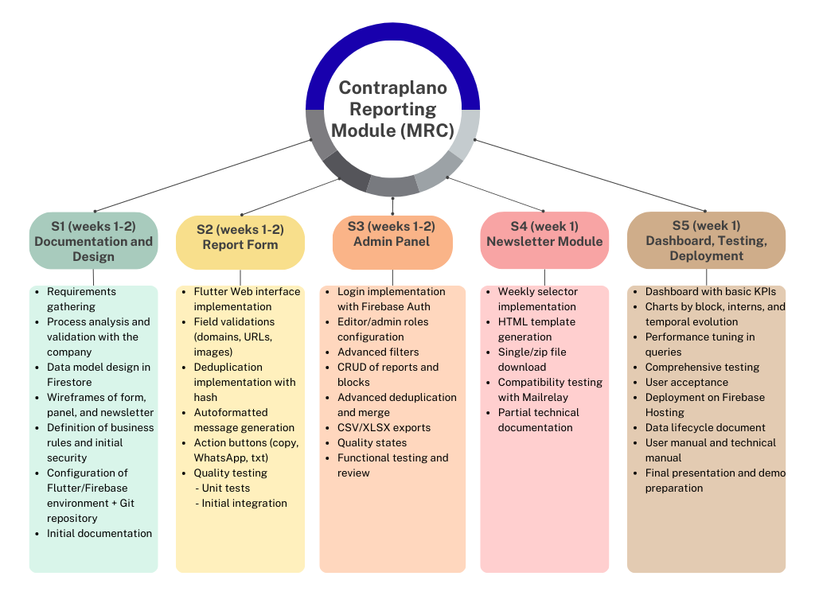

**Summary of planning by weeks and phases**

Start date: 09-01-2025  
End date: 10-26-2025

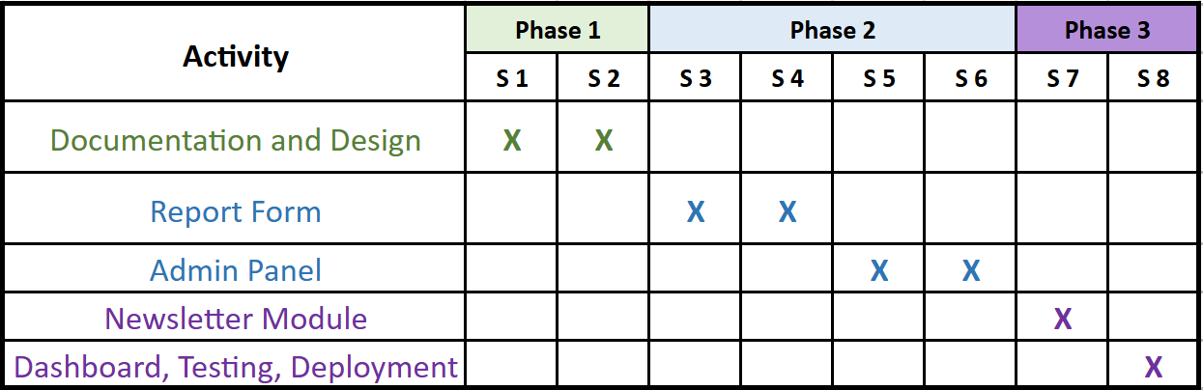

**Use case**

Caso de uso simple o básico más descripción explicativa, leer con calma el manual

**Conclusions**The project represents a significant opportunity to apply academic knowledge in a real-world context. It confirms that IT solutions can add measurable value to organizations by automating and improving existing processes. The MRC not only strengthens Contraplano’s reporting workflow but also provides long-term scalability and maintainability. Professionally, the experience fosters growth in software engineering, data analysis, and project management, while highlighting the need to strengthen complementary skills such as English communication and cybersecurity. Ultimately, this project demonstrates the capacity to transform a practical challenge into an innovative and sustainable solution.